Chapter 3
METHODOLOGY

3.1 Research Design
The Waterfall Development of a Software Development Life Cycle (SDLC) is applied in this thesis. This is primarily because of the clear and exact steps that the model provides for application development. With waterfall development methodology, the advantages of identifying requirements long before programming begins and limiting changes to the requirements as the thesis proceeds.
PLANNING
ANALYSIS
Gather data
DESIGN
Study data gathered
IMPLEMENTATION
Create a system design for TAMIS
TESTING
Pilot Testing
TESTING
Create use case diagram
Create data flow diagram
Create TAMIS

Pilot testing
Create ERD

Figure 3-1: Waterfall Development Model for the Traffic Accident Management Information System
As seen in Figure 3-1, the waterfall development for Traffic Accident Management Information System consists of a number of phases. The planning phase is the gathering of data from the key entities which are the traffic administration, police authority and hospitals. In the analysis phase, the researchers studied the data gathered from the entities and created a use case for TAMIS. For the design phase, the researchers created a system design from the analysis and interpretation of the data gathered and also created a Data Flow Diagram (DFD) and an Entity Relationship Diagram (ERD) for the model of the database. In the implementation phase, the TAMIS was developed as a web application incorporated with the Code Igniter Framework. After the implementation phase, testing was conducted through pilot testing for the systems functionality and usability.

3.2 Requirements Specification
The stakeholders of the TAMIS are the local Road and Traffic Administration, Police Authorities, Hospital or Medical Entities, and the Cagayan de Oro community. In order for the requirements of the system to be identified, Request for Information (RFI) letters were produced and sent to the traffic administration, police authority, and hospital entities. Answers from questionnaire forms attached to the RFI letters and information from interviewing resource persons from the entities have been gathered to get an idea of the requirements and decision-making involved in traffic accident management. Good working knowledge on how the key entities work was necessary for the proponents to develop a system that suits their stakeholders.
The functional requirements of the system have been identified accordingly by studying carefully the current data and functional processes of the traffic accident management in Cagayan de Oro City. Data gathered from research have also been incorporated into the system for the coordination of these entities.
TESTING
Pilot Testing
There are two server installation options for this system to work. The first option is to subscribe a paid web hosting service from any of the reliable web hosting companies available in the internet. The candidate web hosting company should have at least the following core systems installed on their offered hosting package. The following core systems are as follows:
(Refer to Appendix B. B-1 for the Core Systems Required.)
The second option is to setup a locally owned web server and publish it to the internet. The following are the minimum requirements for its hardware and software.
(Refer to Appendix B. B-1 for the Hardware and Software Specifications.)
The latter option was quite expensive and tedious to implement due to some overhead expenses, electricity consumption, for example and not to mention the maintenance of web server systems.
(Refer to Appendix B. B-2 for the Client installation minimum requirements.)
For the broadcasting and receiving of Short Message Service (SMS) alerts in the system, there are also two options available. The first option was to subscribe to a commercial web based messaging platform online. A problem with this option was that not all of these online SMS gateway services are legitimate, working, or even applicable to the county code of the Philippines. The second option was to somehow acquire an SMS gateway device to be locally used by the proponents. A sim card would be used as the mobile number of the system. This option is more costly but can be used easily and without limit.

3.3 Systems Design
The TAMIS for Cagayan de Oro City was implemented as a web application incorporated with the Code Igniter framework. This framework applies the Model-View-Controller (MVC) software architecture because it is in line with the system modules. The model is the domain-specific representation of the data upon which the application operates. The view renders the model into a form suitable for interaction, typically a user interface element. The controller receives input and initiates a response by making calls on model objects. Furthermore, the Windows Apache MySQL PHP (WAMP) web server package is used. Apache Server is deployed, while MySQL is used as the database management system.
The TAMIS has two major features namely – the reports generating feature and the SMS broadcasting feature. These features were put to priority in the making of the system. Everything a call center agent needs in managing traffic accident reports are provided in the system.
In the reports generating feature, traffic accident reports are stored in a database. These traffic accident reports are accumulated and can then be used to generate tables like accident prone areas and different views of traffic accident reports. Website visitors can view the content relating to public knowledge regarding traffic accidents. Accumulated traffic accident reports stored in the database are used to generate reports that can be viewed by the users through the system.
Aside from the SMS broadcast feature, the system is able to receive notifications or prompts similar to Facebook whenever the system receives new messages. This can greatly aid the call center agent in attending to traffic accident reports.
Any job or operation the system cannot comply can be done by the call center agent. The call center agent is the one receiving calls from the caller or the entities.
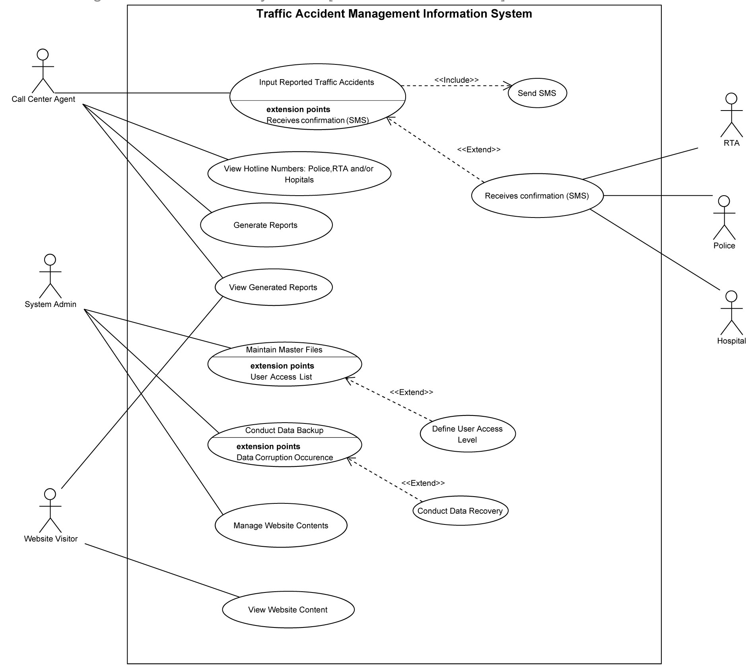
Figure 3-2: Use-Case Diagram for the Traffic Accident Management Information System
Figure 3-2 shows the general overview of the system. As seen in the figure, different kinds of users can benefit from the system. The call center agent is recommended to be a separate entity from the traffic administration, police authority and hospitals. This is mainly to prevent bias. Every traffic accident report is either received by the call center agent if it is a direct call from a caller or is received by the system if it is a text message following the required text formats. Then, the call center agent can call or inform the three entities through SMS using the system. For the system admin, they are the people who maintain master files, conduct data backup and manage website contents. Lastly, the website visitor can view website content and traffic accident reports.
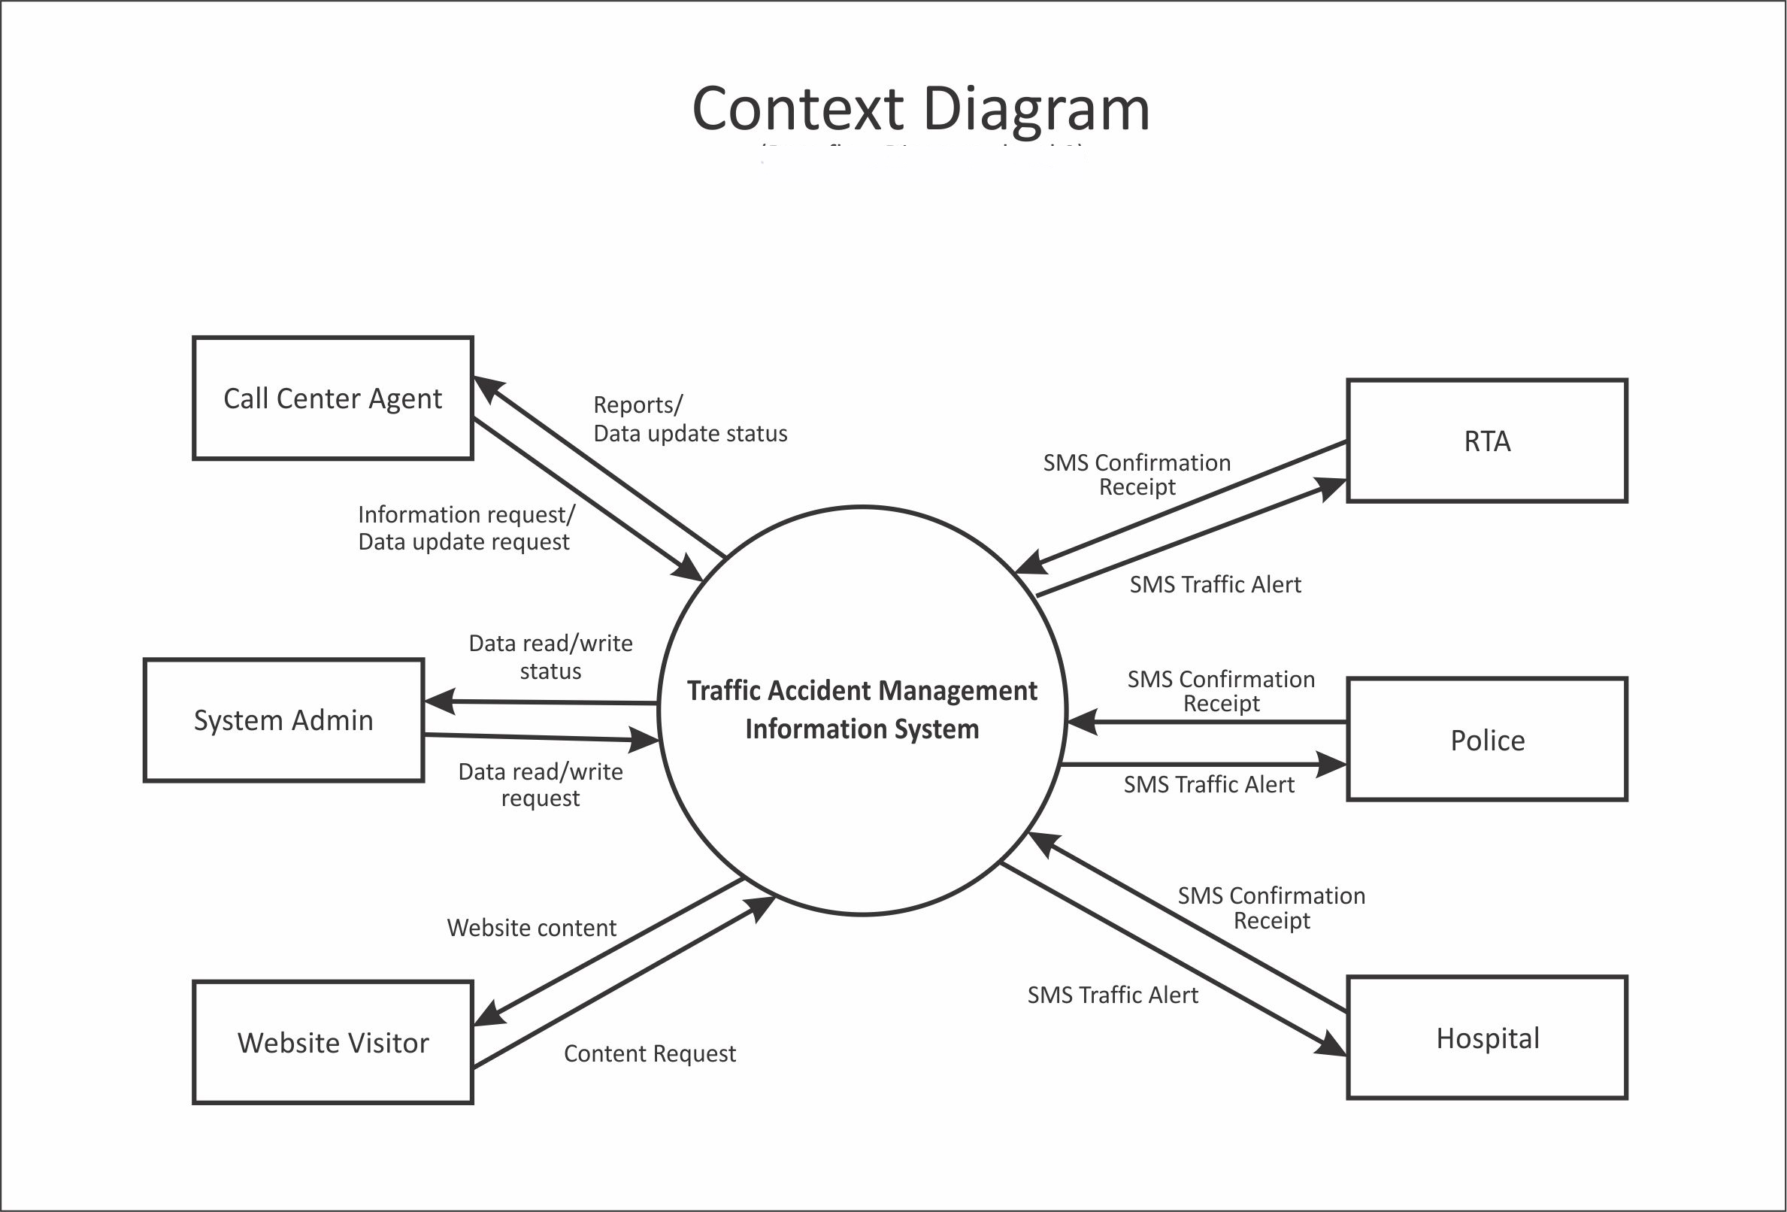
Figure 3-3: The Traffic Accident Management Information System Context Level Diagram
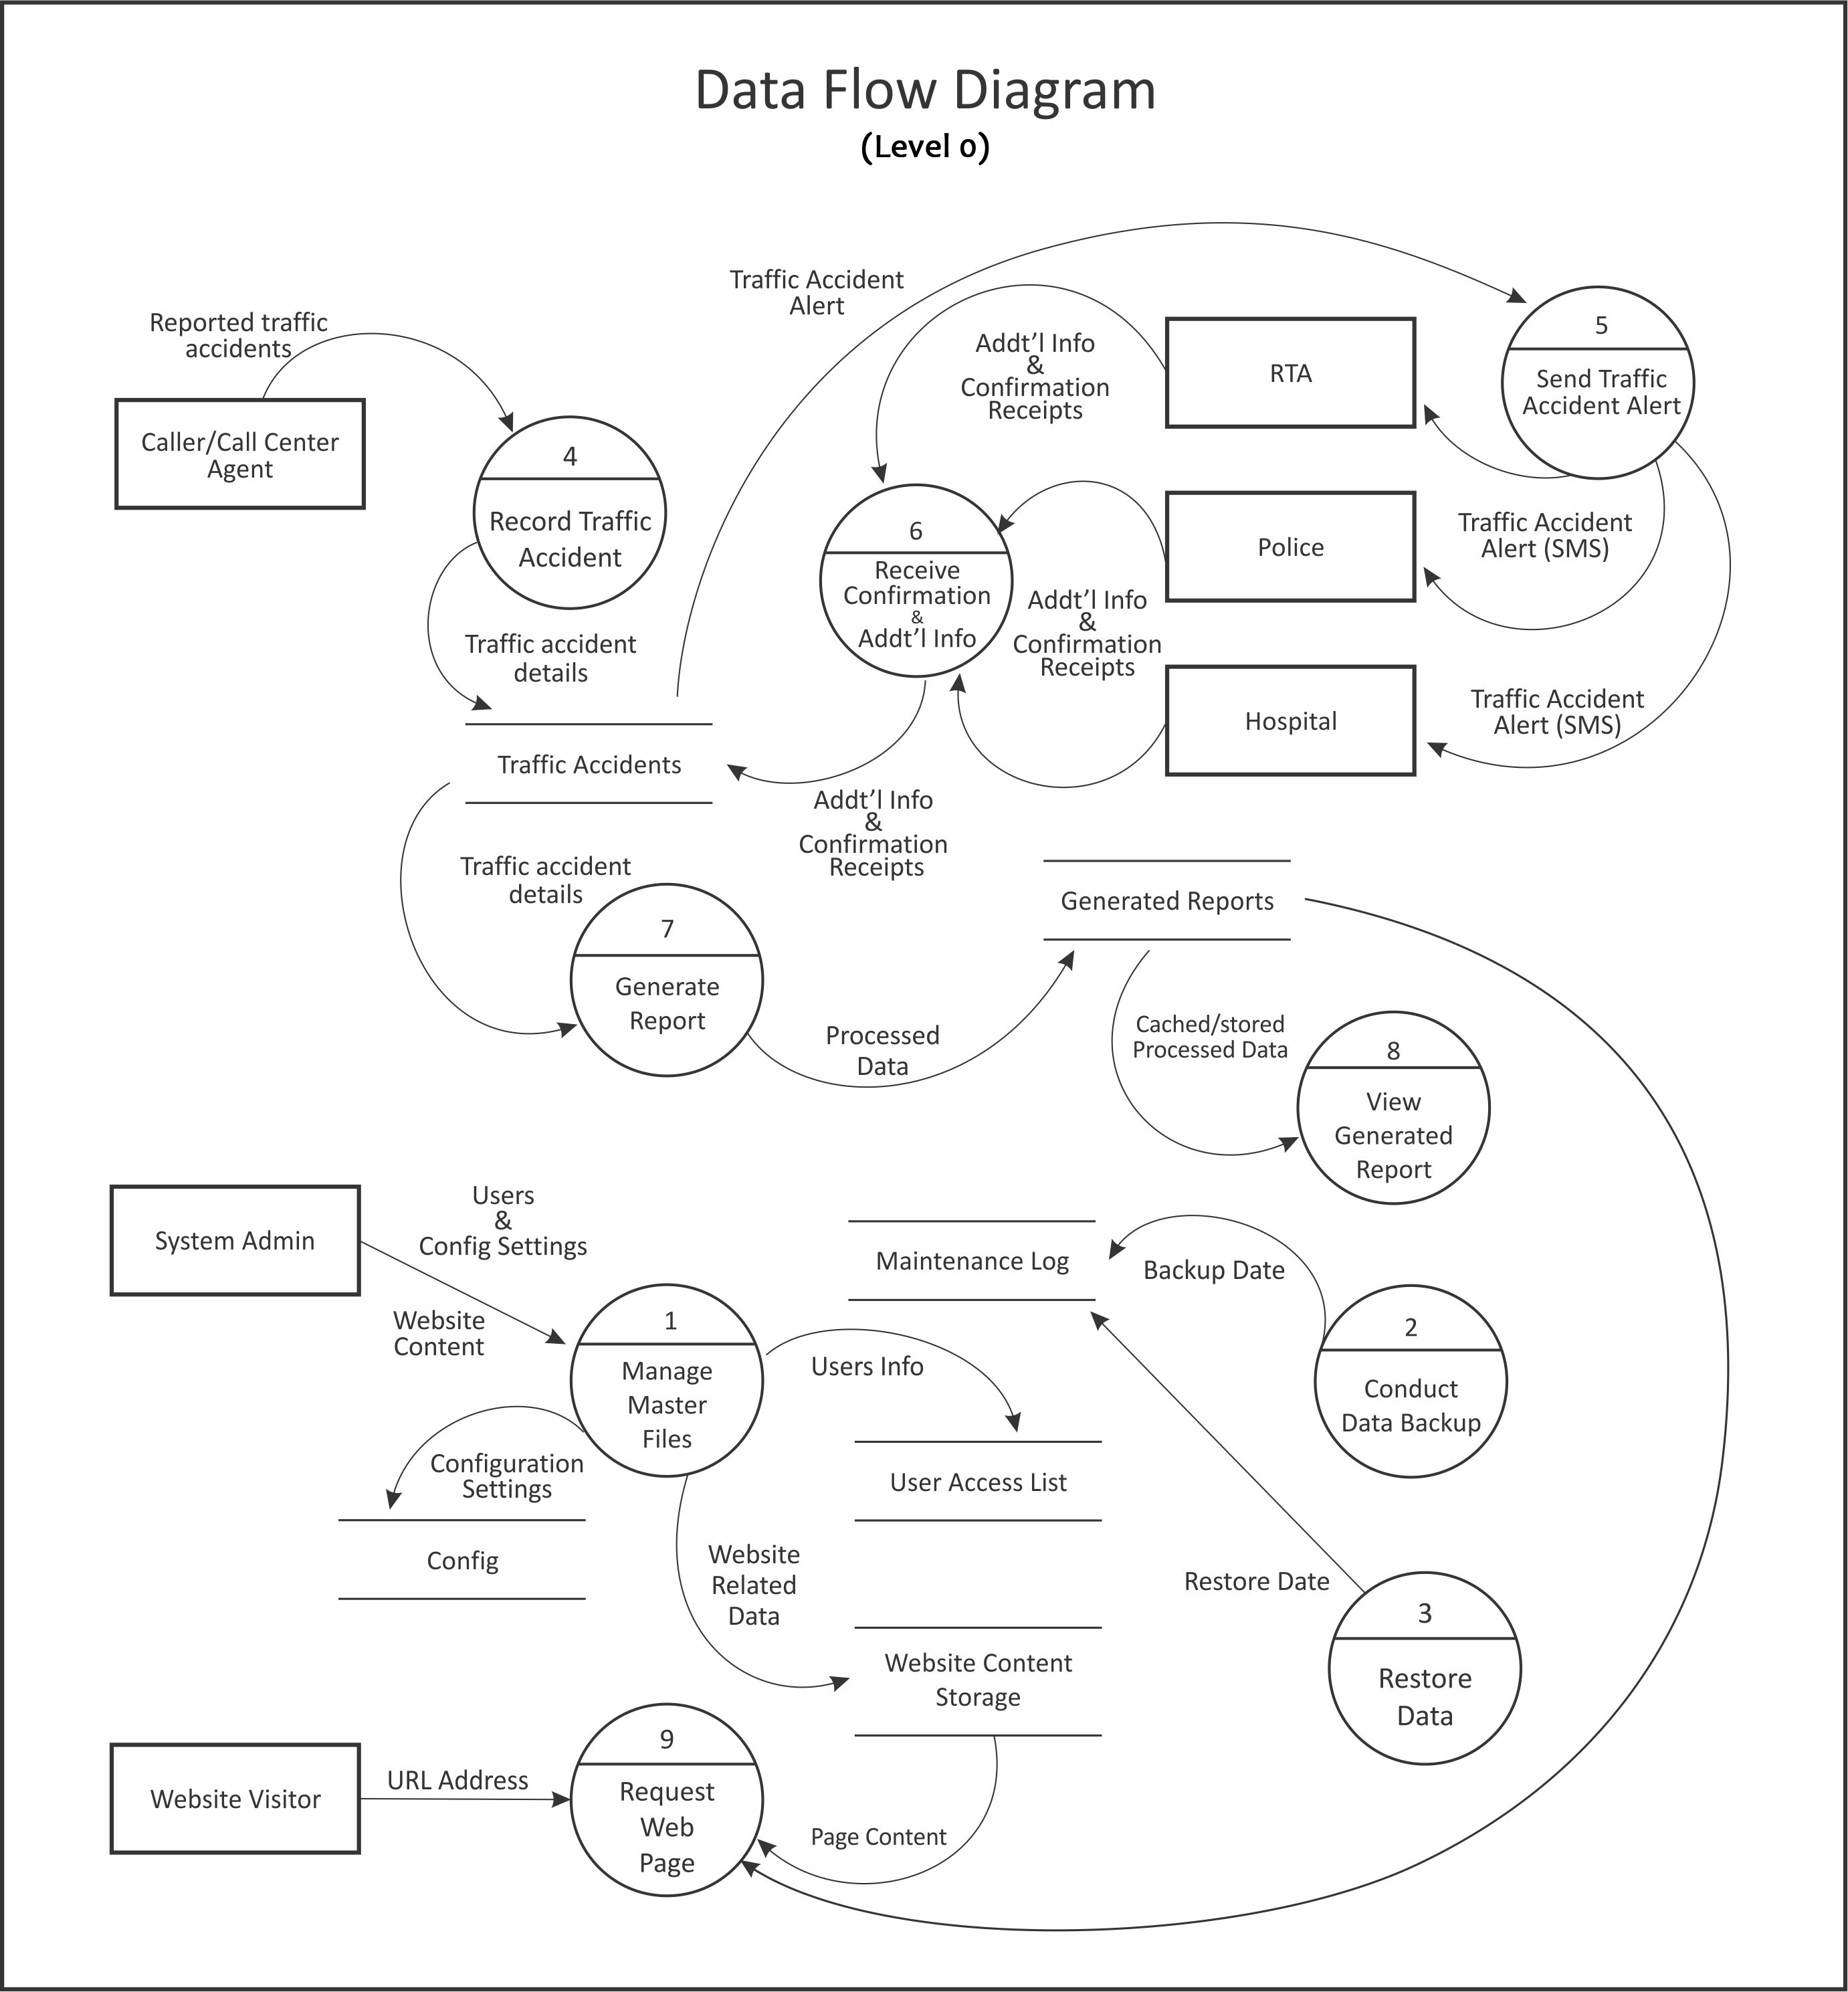
Figure 3-4: Traffic Accident Management Information System Data Flow Diagram
Figure 3-3 shows the Traffic Accident Management Information System context diagram at level 0. TAMIS can be accessed by the following users - Call Center Agent, System Admin, and Website Visitor respectively. The users of the system can be distinguished by their user levels and assigned functions. The system can also address all the needs and services necessary for traffic accident management. It can handle information requests, update status and reports by the call center agent. It can provide the system admin with data modification functions. It can allow website visitors to view its content relating to public knowledge regarding traffic accidents. Most importantly, the system can alert the traffic administration, police authority, and hospital entity contact persons of accident reports through SMS.
In Figure 3-4, the flow of data in the Traffic Accident Management Information System is illustrated in detail. The reported traffic accident data received by the call center agent goes through the input form in the system to be recorded and stored. This data to be accumulated can then be used to generate reports that can be viewed by the users through the system.
User and configuration settings including web content data by the system admin goes through the master files interface in the system. This is where the system admin can save his/her preferred settings, view user information and manage website related data. The website content stored by the system admin can then be viewed by the website visitors.
A backup data system is also equipped in the system to protect the data in cases of system failures or breach. There would be a regular data backup maintenance. It can either be system or user triggered. The stored backups can then be restored by user or by system request.
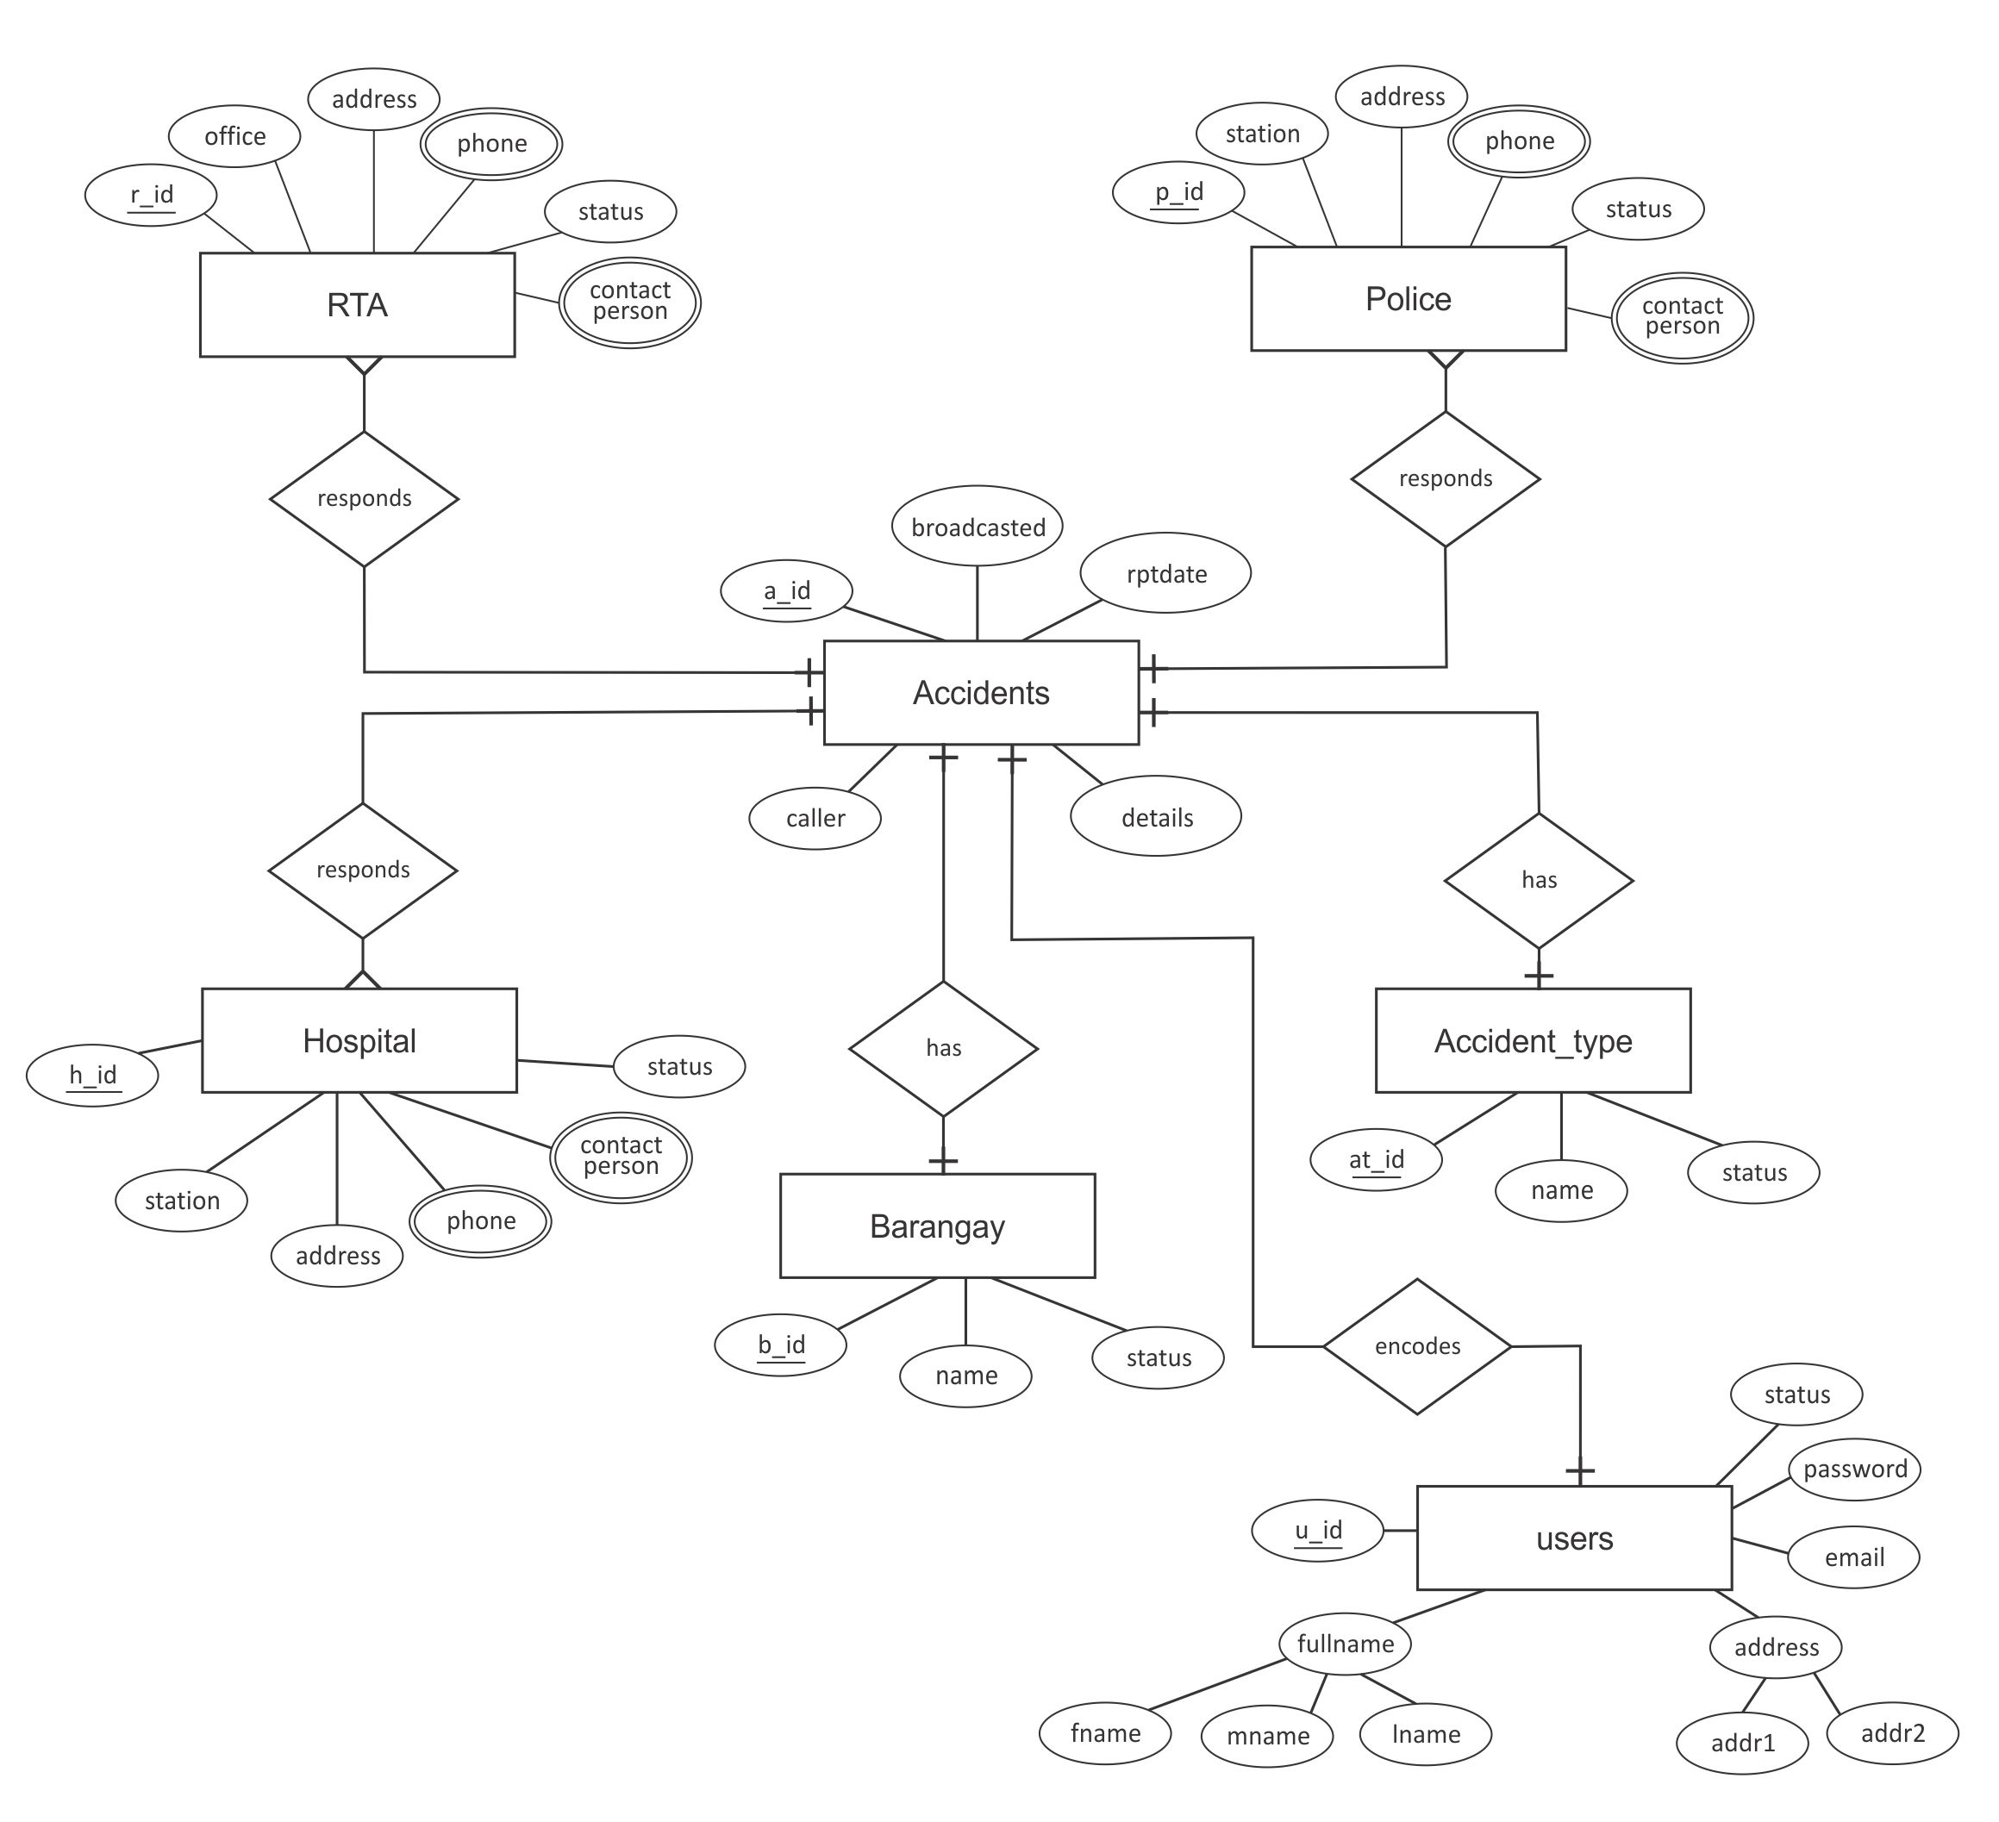
Figure 3-5: Entity Relationship Diagram of the Traffic Accident Management Information System Database

Figure 3-5 shows the Entity Relationship Diagram of the system database. The database consists of the RTA, Police, Hospital, Barangay, Accident Type, Users, and Accidents entities. The Accidents entity has a relationship with all the other entities in the database. This is the main focus of the system database.
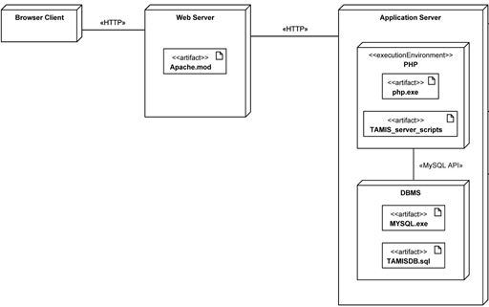
Figure 3-6: The Deployment Diagram for Traffic Accident Management Information System

Figure 3-6 shows how the system is deployed to the following hardware. It started with the browser client. It is then set up with a web server. It also makes use of an application server where the scripts reside or are hosted.

3.4 Programming and Prototyping
Adobe Dreamweaver is used since it is an Integrated Development Environment (IDE) and its main focus is to author HTML pages. This can also be used for making and editing other types of scripts like JavaScript, Action Script, PHP, CSS, and ColdFusion. In the context of the development of TAMIS, this was used for its HTML authoring capabilities, CSS and JavaScript.
Eclipse for PHP is just another powerful and versatile Integrated Development Environment (IDE), which is an open source application. The proponents used this because it has rich features in terms of coding in the sense of object-oriented programming, such as outline layout or exposing methods of objects and variables for the ease of navigation from line to line of codes, code hinting, color coding, and many more advanced features.
Adobe Photoshop was the bitmap graphic application used for designing the Graphical User Interface (GUI) of TAMIS.
Filezilla is a client application tool that was used for the sole purpose of transferring files remotely from web server to client and vice-versa.
Git is free software distributed under the terms of the GNU General Public License. It is a source code management system. The use of Git in the development of the TAMIS is to have repository or working files on a cloud or the internet. The software has a revision control that enables the development team to revert their working files to the desired version of the system. The proponents used this to aid in group collaboration in writing codes of the system. It can be used for uploading all kinds of documents to the server for the proponents to access, commit changes done to the code, and most especially tract the version number of the current system project and synchronize all local copies of each proponent upon a request of update from the version control system.

3.5 Testing
Testing plays a crucial part in this systems development life-cycle process. This can provide an effective system that the Cagayan de Oro community can depend on for their day to day commuting. Pilot Tests were conducted and assessed to determine whether or not the objectives were properly met and satisfied upon the implementation of the system and that it is fully functional or bug-free.
Pilot testing involved ten people chosen by the proponents who acted as callers and supplied sample traffic accident report records or inputs. Contact numbers of four chosen people were substituted for those from police authorities, traffic administrators, rescue groups, and hospitals who are supposedly the contact persons of the system. These contacts were the ones who received the automated SMS messages from the TAMIS when traffic accident data were acquired.

3.6 Evaluation
After testing, the evaluation on the functionality of TAMIS was conducted. Rubrics that specifically rated the SMS broadcasting feature of the system were made by the proponents. The rubrics have a scale of four: 4 - Exceeds expectations, 3 - Meets expectations, 2 - Progressing, and 1 - Not there yet. The rubric for the caller and the entities in testing the system includes the criteria on the functionality to send SMS to the system, to receive SMS from the system and to receive follow-up SMS confirmation from the system. For the caller alone, there is a criterion on the functionality to receive follow-up SMS from the system.

